Stress-testing conservation strategies under uncertain future socio-environmental changes reveals which approaches best protect future ecosystem service provision

Conservation planning is often grounded in static views of today’s landscapes. Our research shows how simulation modeling across future scenarios can guide adaptive strategies and reveal synergies among competing conservation objectives.

2026-02-03

Area-based conservation is the primary strategy for preserving biodiversity, yet current planning often overlooks two key uncertainties: future socio-environmental drivers of degradation and preferences for alternative conservation objectives. In a recent article in the *Journal of Environmental Management*, we show how spatial conservation prioritization can be combined with scenario-based simulation modeling to evaluate strategies under these uncertainties. We simulated conservation area expansion in Switzerland from 2020 to 2060, testing all strategies across five scenarios of climatic, demographic, and economic change using a land use and land cover change model. Strategy robustness was assessed through spatio-temporal impacts on ten ecosystem services.

Results showed strong variation in ecosystem service provision across alternative futures, with major spatial shifts in service delivery. Only limited overlap existed between areas with the highest ecosystem service robustness and those prioritized based on current ecological value, highlighting the limitations of planning approaches that ignore future uncertainty. The most robust strategy involved rapidly expanding conservation areas to 30% coverage, consistent with the Kunming-Montreal Global Biodiversity Framework, prioritizing small patches in human-dominated landscapes, and applying mixed management that combined preservation and restoration. However, effectiveness differed across ecosystem services and scenarios, indicating that conservation planning must reflect societal preferences. These findings offer actionable guidance for Switzerland’s pursuit of the 30x30 target, underscoring the need for immediate action and for protecting distributed small patches in lowland regions rather than focusing solely on large alpine reserves.

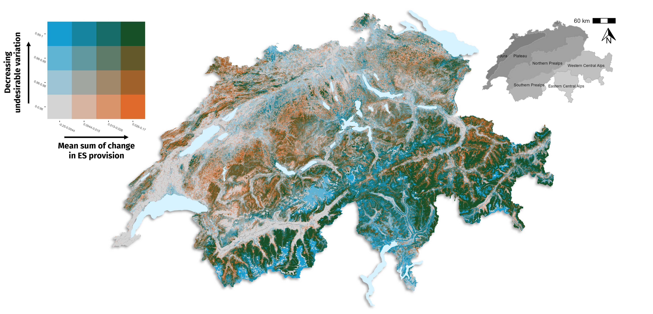

Bivariate map summarizing two dimensions of the robustness of future ES provision across the simulated scenarios and conservation strategies: a measure of performance on the x-axis of the legend (mean cumulative sum of change between 2020 and 2060) and variability on the y-axis (normalized undesirable deviation, UD)

The full article can be found [here](https://doi.org/10.1016/j.jenvman.2025.128395)